**ASSIGNMENT 35.2**

Incremental import is a technique that imports only the newly added rows in a table. It is required to add ‘incremental’, ‘check-column’, and ‘last-value’ options to perform the incremental import.

The following syntax is used for the incremental option in Sqoop import command.

--incremental <mode>

--check-column <column name>

--last value <last check column value>

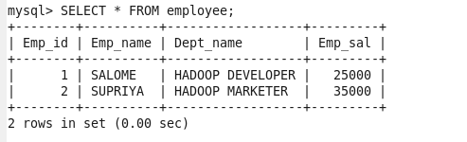

**Add rows into employee table using mysql**

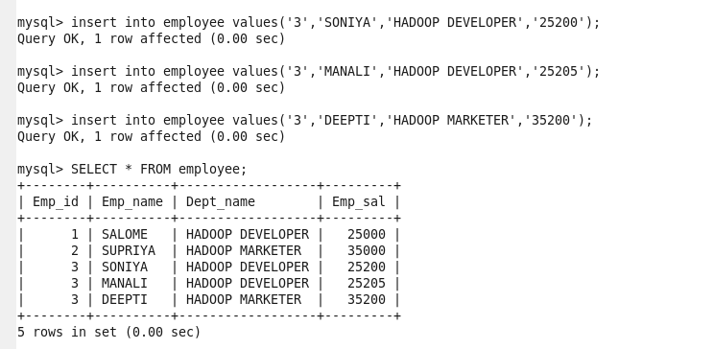

**Incremental import:**

